Natural gas crisis in Europe revamps green chemicals into win-win solutions
Abhinandan Nabera, Ioan-Robert Istrate, Javier Pérez-Ramírez and Gonzalo Guillén-Gosálbez*
Institute for Chemical and Bioengineering, Department of Chemistry and Applied Biosciences, ETH Zürich, Vladimir-Prelog-Weg 1, Zürich 8093, Switzerland
*Corresponding author: gonzalo.guillen.gosalbez@chem.ethz.ch

Context and scale
Ammonia and methanol are two of the most important chemicals which are used in our daily lives. Both these chemicals majorly use natural gas as a feedstock for their production which results in higher CO₂ emissions. A variety of research has been carried out in abundance to produce these chemicals in a more environmentally sustainable manner. However, the economics of such alternative routes of production was found to be infeasible. Nonetheless, the current scenario in Europe paints a different picture when natural gas prices become volatile. In this work, a cost-benefit analysis of the changing production costs for fossil ammonia and methanol is compared with the greener routes of production as a result of the current state of affairs in Europe. In addition to emitting less CO₂, the alternative routes of production were found to be cost competitive and, in some cases, even cheaper than their fossil counterparts.

Summary

Green hydrogen produced via water electrolysis using renewable electricity sources is a possible alternative to lower greenhouse gas (GHG) emissions related to ammonia and methanol production. However, the economics of green hydrogen acts as a bottleneck making this route infeasible. Here, we show that these alternative routes of production become economically feasible in the current scenario where natural gas prices are skyrocketing majorly due to the geopolitical outline. Green ammonia produced from hydrogen via water electrolysis using on-shore wind electricity was found to be economically competitive or similar (<5%) to the fossil route for nine months since October 2021. The lowest feasible monthly average production cost for wind-based ammonia was around 1,166 USD t⁻¹ in October 2021 in comparison to 1,155 USD t⁻¹ for the fossil route. Similarly, wind-based methanol was found to be economically feasible in comparison to fossil methanol for one month during the peak of natural gas prices in Europe. This study makes us realize the importance and need of the hour to invest in alternative routes for the production of chemicals starting with ammonia and methanol.

Introduction
The chemical industry is the industrial sector with the highest energy demand as it uses fossil fuels both as feedstock and fuel. About 14% and 8% of global oil and gas, respectively, are consumed by the chemical industry¹, which is also responsible for 5.6 Gt CO₂-eq per year (including direct and indirect emissions), equivalent to roughly 10% of global anthropogenic GHG emissions^{2,3}. Out of all the chemicals, ammonia, methanol, ethylene, and propylene are the major building blocks of the chemical industry which are further used as raw materials for the production of valuable products. Notably, ammonia is critical to the production of fertilizers and to ensure global food security⁴, while methanol is largely used for the production of valuable products (e.g., formic acid, acetic acid, dimethyl ether, and methylamine) and can serve as an intermediate to olefins and aromatics⁵. Ammonia is predominantly produced via the Haber-Bosch process using natural gas as feedstock and is responsible for one-fourth of the total fossil fuel consumption in the chemical industry⁶. Similarly, methanol relies on natural gas or coal for the production of syngas which is then converted to methanol via the water-gas shift reaction.
Ammonia and methanol are hard-to-abate chemicals primarily due to their strong dependence on natural gas as feedstock. Hence, shifting to renewable feedstocks is paramount to mitigate their climate impacts^{7,8}. Low-carbon ammonia production is possible by replacing the steam methane reforming (SMR)-based hydrogen with electrolytic hydrogen powered by wind or solar energy⁹. Moreover, carbon capture and utilization (CCU) offer a route to 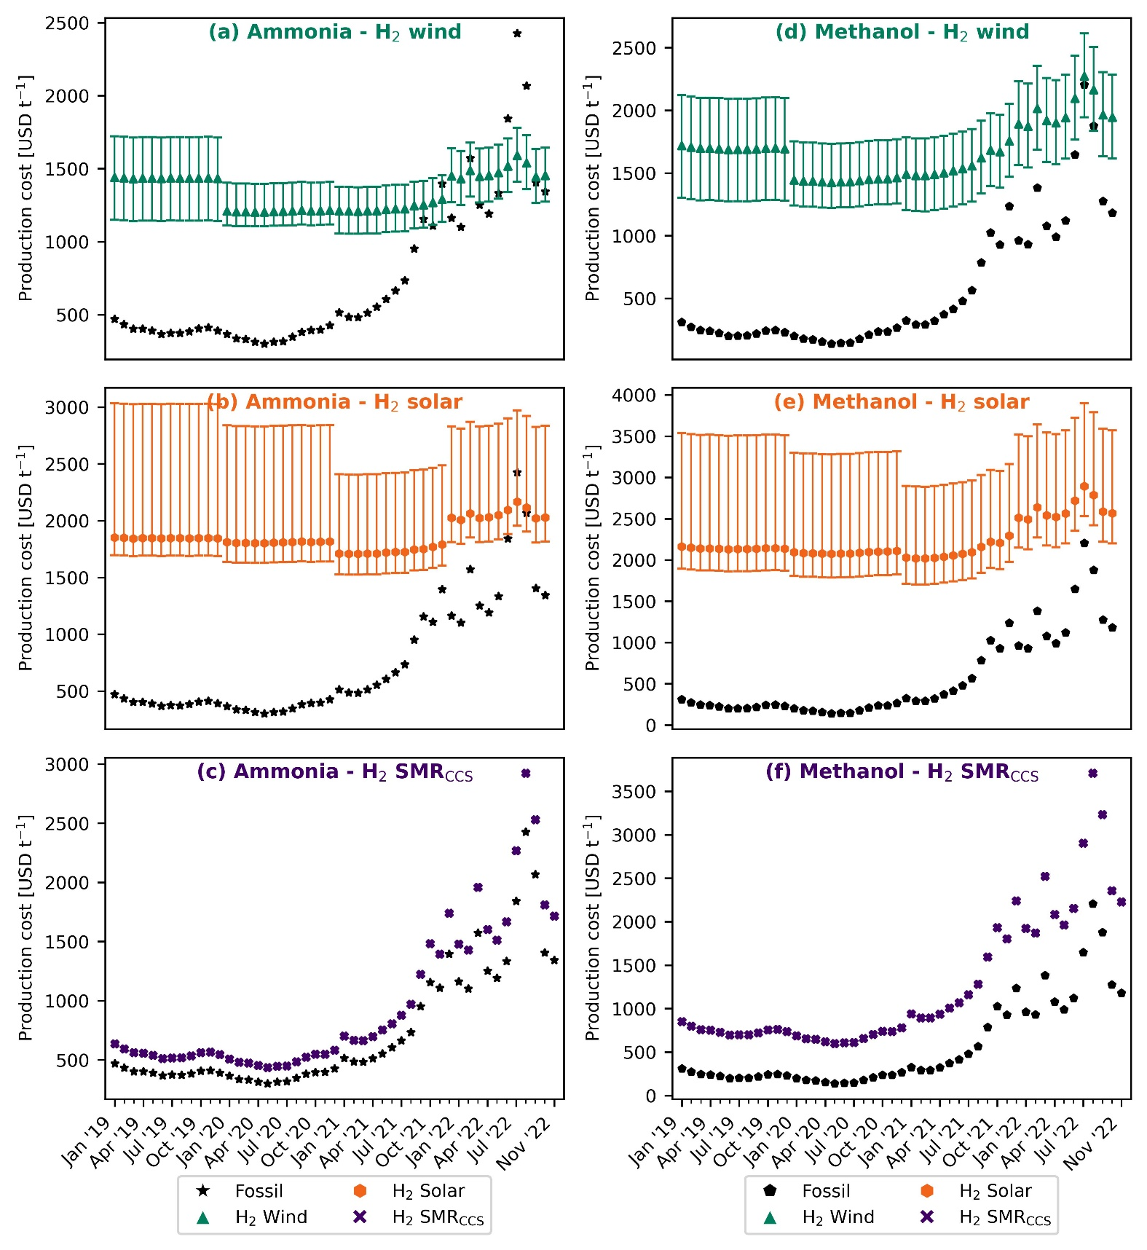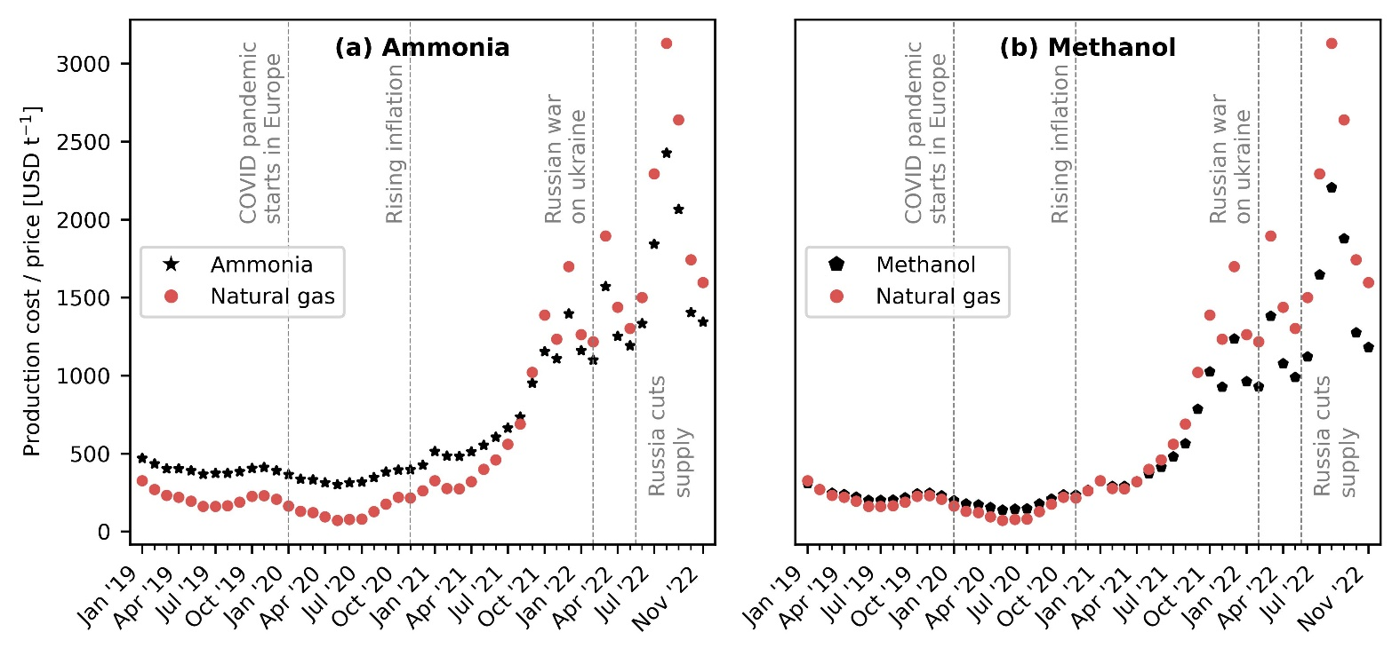decarbonize methanol production via CO₂ hydrogenation¹⁰. Prior works have demonstrated the technical feasibility¹¹ and potential climate benefits^{9,12-14} of green chemical production routes, but the high costs remain a major barrier to their implementation¹⁵. Literature estimates suggest that green ammonia and methanol cost twice as much as the natural gas-based counterpart^{9,10}.
The economic viability of green chemicals has been largely hampered by the high costs of renewable feedstocks (i.e., hydrogen and captured CO₂) compared with natural gas^{9,10}. However, natural gas has seen a sharp increase in prices over the last two years, primarily due to the COVID-19 pandemic, skyrocketing inflation, and the global energy crisis caused by the Russian invasion of Ukraine. In Europe, which is particularly affected by the new geopolitical scenarios, monthly average natural gas TTF spot prices have increased from 560 USD t⁻¹ in July 2021 to 2,300 USD t⁻¹ as of July 2022¹⁶. Similarly, the price of grid electricity has almost quadrupled¹⁷. The drastic increase in natural gas and electricity prices has severe consequences for the European chemical industry. For example, recent news suggests that more than half of Europe’s ammonia production capacity (estimated at around 19 Mt a⁻¹)¹⁸ has been shut down due to gas prices^{19,20}.
The energy crisis in Europe can in principle help make green chemicals more economically appealing while laying the foundation for a renewable transition in the European chemical industry. However, whether green chemicals represent win-win solutions (understand as a Pareto improvement²¹: simultaneous reduction of costs and GHG emissions) in the present state of affairs has not been explored yet. In this work, we calculate the production and CO₂ avoidance costs for fossil and green ammonia and methanol in Europe considering the impact of natural gas price fluctuation.
Results
Cost comparison between the fossil and green routes of production
Considering the natural gas spot prices in Europe as of November 2022, we estimate the production cost of fossil ammonia at around 1,344 USD t⁻¹, which is two times higher in comparison to July 2021. When natural gas prices reach around 1,400 USD t⁻¹ (October 2021), green ammonia produced with hydrogen from water electrolysis using on-shore wind electricity turn cost-competitive with fossil ammonia (Fig. 1a). Based on monthly average natural gas spot prices, ammonia production via wind electrolysis has been cheaper than or similar to fossil ammonia for nine months since October 2021. Whereas green ammonia produced via solar-based electrolytic hydrogen is only feasible around the peak of natural gas prices in August 2022 (Fig. 1b). This can be attributed to lower capacity factors (16.1 to 17.5%) in comparison to wind electricity (35.6% to 39%) resulting in higher levelized costs of hydrogen²². Ammonia production with blue hydrogen – SMR coupled with carbon capture and storage (CCS) – is always more expensive than the conventional route due to the additional cost of CCS and extra nitrogen feed (Fig. 1c).
Similar to ammonia, the cost of production for fossil methanol has increased sharply. In comparison to July 2021, the estimated production cost for fossil methanol rose by 146% in November 2022, reaching 1,181 USD t⁻¹. At natural gas prices of around 3,100 USD t⁻¹, green methanol produced with wind-based hydrogen is economically competitive (Fig. 1d). However, the break-even natural gas price largely depends on the levelized cost of hydrogen and could decrease to 2,300 USD t⁻¹ if considering the lower end of the hydrogen cost range. The solar-based route, however, follows a different trend to that seen for ammonia and is never feasible even at the peak of natural gas prices (August 2022) (Fig. 1e). For the case of blue hydrogen from SMR + CCS, the cost of production is on average 182% higher than conventional methanol due to the additional cost of CCS and captured CO₂.
To investigate further, Fig. 2 shows the breakdown of production costs for fossil chemicals and wind-based green routes at different time points. We take average values for the years 2019 and 2020 as the natural gas and electricity prices before July 2021 were approximately constant. Notably, the contribution of natural gas to the average production costs for fossil ammonia increased from 21% in 2020 to 44% in July 2021 and up to 63% in November 2022 (Fig. 2a). Similarly, the contribution of electricity increased from 8% in 2020 to 12% in November 2022. Green hydrogen from wind electrolysis has the highest share (67% to 84%) of the production cost for green ammonia. Since wind electricity is used only for the electrolyzer, whereas for the compressors we consider grid electricity, the share of grid electricity rose from ∼1% in 2020 to 6% in November 2022.

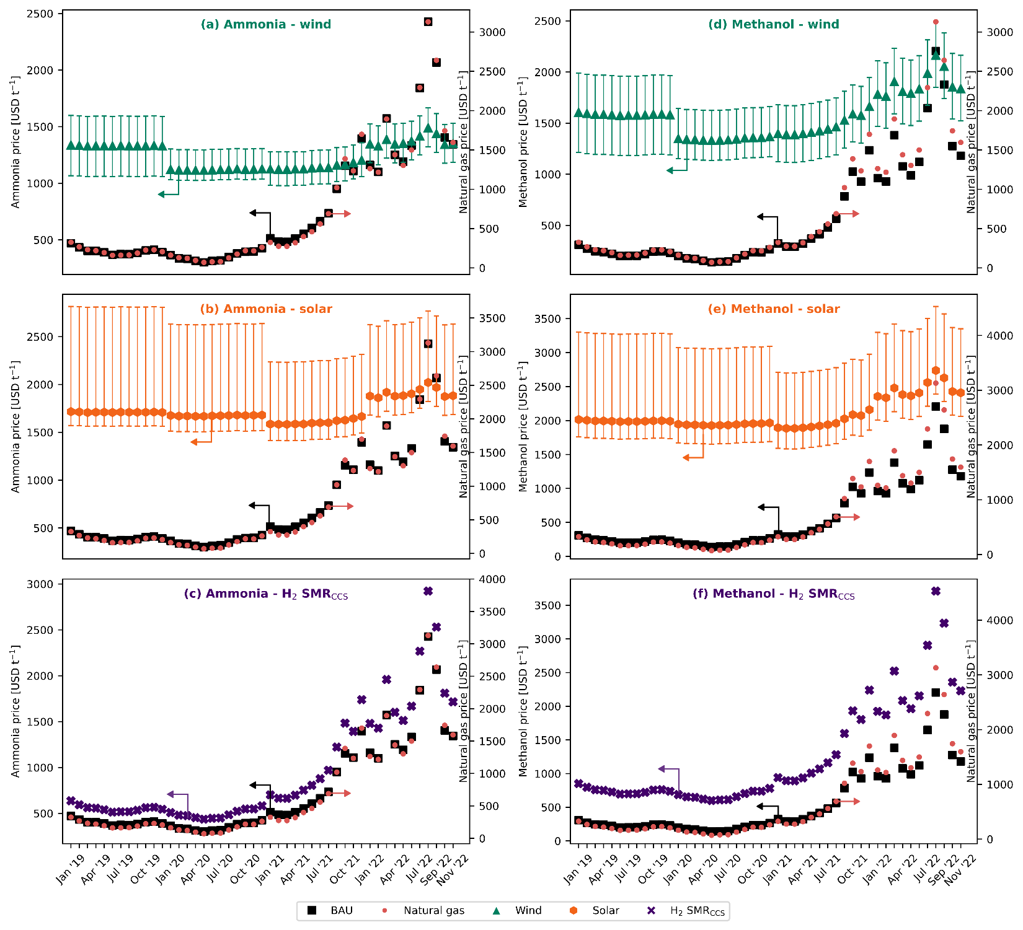
Fig. 1. Evolution of the production cost for fossil and green ammonia and methanol under the European spot price for natural gas. The error bars display the production cost considering the lower and upper bound for the levelized cost of hydrogen²².
Similarly, for the production of fossil methanol, the share of natural gas increased from 48% in 2020 to 76% in July 2021, and 88% in November 2022 (Fig. 2b). The contribution of electricity stood at around ∼1% during the entire period considered in our analysis. Hydrogen from wind electrolysis has the highest share of around 65% in July 2021 which decreased to 58% in November 2022 for the green methanol production route. The share of CO₂ from DAC was about 17% in 2020 and increased to 29% in November 2022. This increase can be attributed to the increase in natural gas prices which is required for the capture of CO₂ via DAC.
CO₂ avoidance costs

The CO₂ avoidance cost follows an inverse trend to the natural gas price (Fig. 3). In 2020 at an average natural gas price of 145 USD t⁻¹, wind- and solar-based ammonia result in an avoidance cost of 513 and 1,259 USD t⁻¹ CO₂, respectively. This cost is substantially higher for methanol with 1,327 and 7,104 USD t⁻¹ CO₂, respectively, primarily due to a higher difference between the production costs of fossil and green methanol. Notably, the avoidance cost of green ammonia and methanol in 2020 largely surpasses the removal cost of bioenergy with carbon capture and storage (BECCS) and DAC with carbon capture and storage (DACCS), forecasted at 100-200 USD t⁻¹ CO₂ and 100-300 USD t⁻¹ CO₂, respectively²³. However, as natural gas prices increase, less money is required for every ton of CO₂ emission avoided by switching from fossil to green chemicals. At the peak of natural gas prices in 2022, the avoidance cost of green ammonia and methanol becomes negative, meaning that the industry could simultaneously reduce costs and CO₂ emissions. Since July 2021, the industry could save around 123 to 625 USD t⁻¹ CO₂ avoided via the wind-based route for ammonia production. Similarly, in August 2022 for methanol via wind, savings stood at around 46 USD t⁻¹ CO₂ avoided.

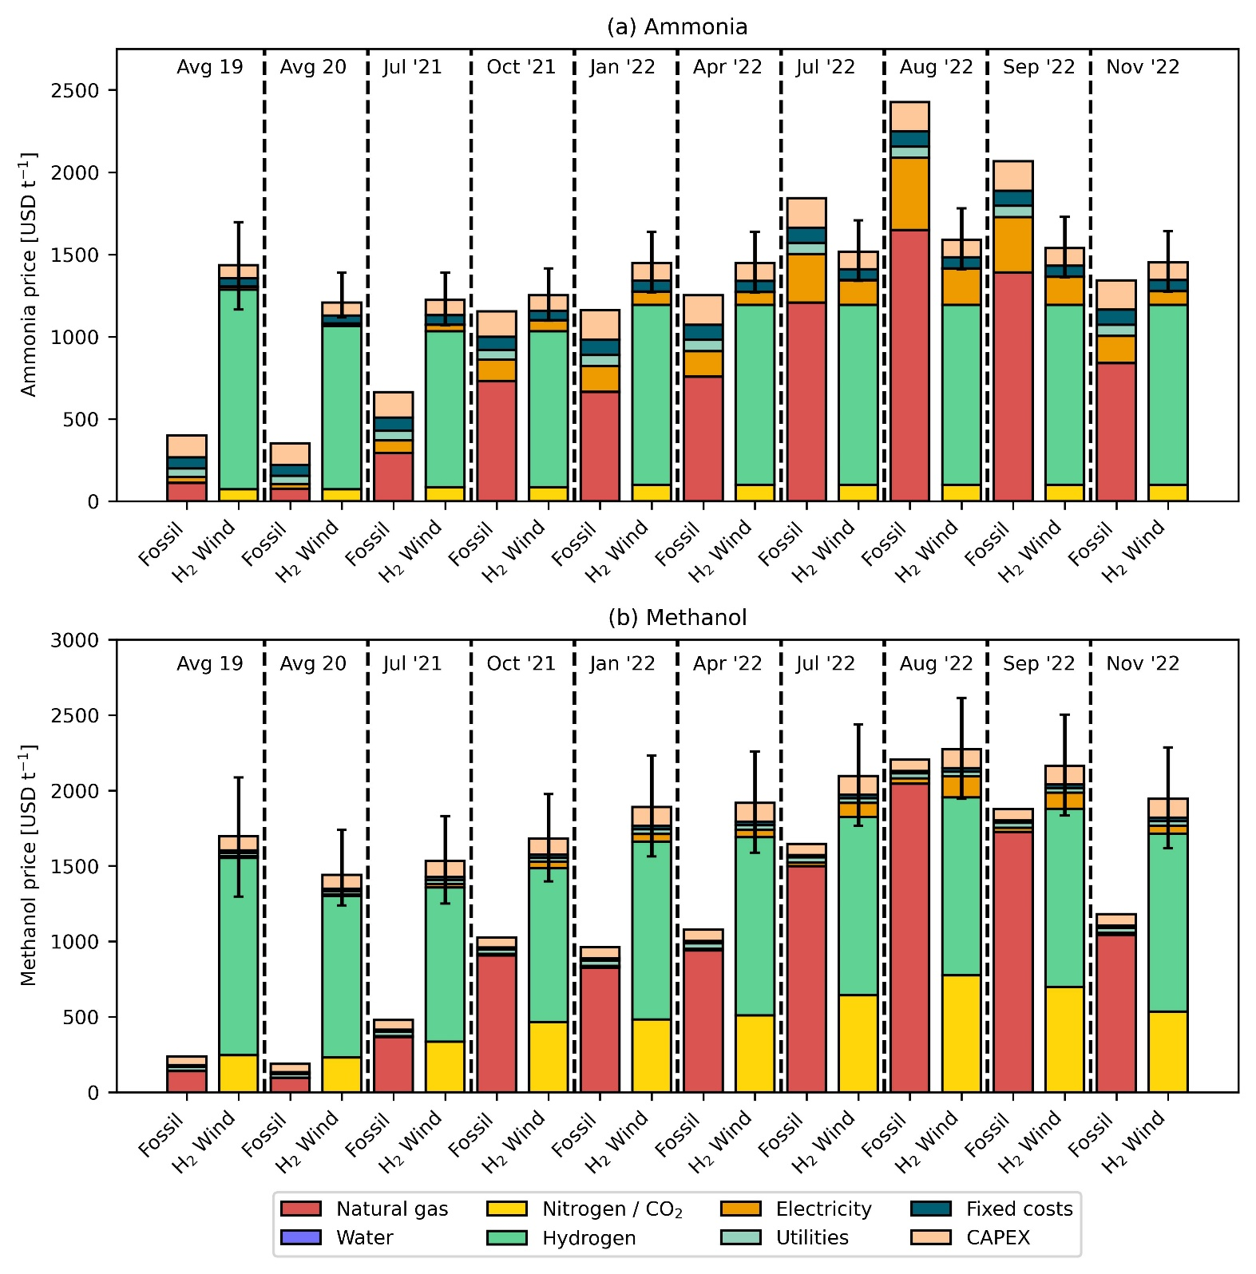
Fig. 2. Breakdown of production costs for fossil and green ammonia (a) and methanol (b). The green route uses hydrogen from water electrolysis using on-shore wind electricity and CO₂ from direct air capture (DAC). The error bars display the production cost considering the lower and upper bound for the levelized cost of hydrogen²².

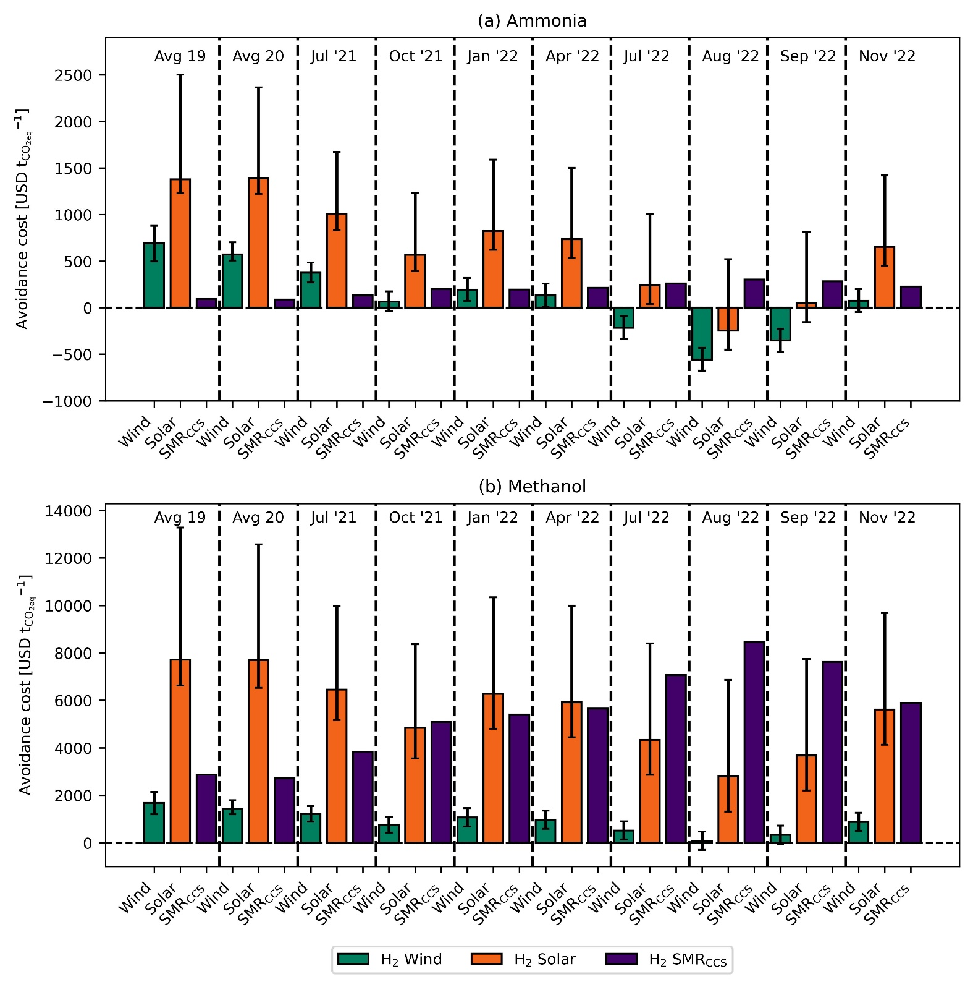
Fig. 3. CO₂ avoidance costs for green ammonia (a) and methanol (b). The error bars display the production cost considering the lower and upper bound for the levelized cost of hydrogen²².
Discussion
While the current energy crisis faced in Europe is exceptional, natural gas prices are predicted to remain high (1,579 - 2,216 USD t⁻¹) for the next few years²⁴. On the contrary, the costs of renewable energy technologies are expected to decrease²⁵. For that reason, ammonia production from wind could be the most promising technology in the foreseeable future. Identical to the case of ammonia, methanol production via wind is expected to be cost-competitive with fossil methanol in the coming future.

Experimental procedures
Scenarios definition. Three alternative routes for the production of ammonia and methanol are considered. The only difference in the three cases is the source of hydrogen. The different sources of hydrogen considered are water electrolysis using on-shore wind electricity, water electrolysis using solar electricity, and steam methane reforming with carbon capture and storage (SMR + CCS). For all the ammonia production alternatives, along with hydrogen, nitrogen from cryogenic air separation is used as a feedstock. Whereas, in the case of conventional ammonia, nitrogen comes from the air which is used in the autothermal reactor⁹. For methanol production, all three alternative production routes use CO₂ from direct air capture (DAC) as a feedstock. Therefore, CO₂ and hydrogen undergo the reverse water gas shift reaction to produce syngas, and syngas is converted to methanol in the following step.
Economic assessment. The material balances and energy flows for both fossil and green ammonia are extracted from the work done by D’Angelo et al.⁹. In the case of fossil ammonia, every ton of ammonia produced consumes 0.53 tons of natural gas and 940 kWh of electricity. The prices of feedstock and utilities other than natural gas, electricity, and hydrogen are extracted from D’Angelo et al.⁹ and adjusted for inflation. The monthly average natural gas TTF spot prices from World Bank²⁷ and electricity prices from Ember¹⁶ are used for all our calculations. Further, the levelized cost for on-shore wind and solar electricity and their corresponding capacity factors are extracted from IRENA for the years 2019 to 2021 (except 2022)^{28,29,30}. Using these values, the levelized cost of hydrogen (LCOH) is calculated following the assumptions and equations provided in the work carried out by D’Angelo et al.⁹. Due to the lack of availability of similar data for the year 2022, the levelized cost of electricity (LCOE) is adjusted with inflation to calculate the LCOH for the specific year. Similarly for methanol, the material balance and energy flow for both fossil methanol and green methanol are extracted from González-Garay et al.¹⁰. Every ton of fossil methanol produced consumes 0.65 tons of natural gas and 74 kWh of electricity. The prices of natural gas, electricity, and hydrogen are substituted by the aforementioned extracted and or calculated prices, and all the other costs are adjusted for inflation. The price of CO₂ from DAC is extracted from Keith et al.²⁶ and recalculated with the new natural gas prices. For every ton of CO₂ captured, 0.11 tons of natural gas is required²⁶.
CO₂ avoidance costs. The CO₂ avoidance costs in USD t⁻¹_{CO2eq} are calculated as follows:
$${\text{CO}}_{\text{2}}\text{ avoidance costs [}\frac{\text{USD}}{{\text{t}}_{{\text{CO}}_{\text{2eq}}}^{\text{-1}}}\text{] =} \frac{{\text{P.C}}_{\text{ALT}}\text{ -} {\text{P.C}}_{\text{BAU}}}{{\text{GWP}}_{\text{BAU}}\text{ -} {\text{GWP}}_{\text{ALT}}}$$
where P.C_{BAU/ALT} represents the production cost in USD t⁻¹ for the fossil (BAU) and alternative (ALT) routes. Similarly, GWP_{BAU/ALT} represents the global warming potential in t_{CO2eq} t⁻¹ for the fossil (BAU) and alternative (ALT) routes of production.
References
- IEA (2018). The Future of Petrochemicals: Towards more sustainable plastics and fertilisers (International Energy Agency).
- Bauer, F., Tilsted, J.P., Pfister, S., Oberschelp, C., and Kulionis, V. (2023). Mapping GHG emissions and prospects for renewable energy in the chemical industry. Current Opinion in Chemical Engineering 39, 100881. 10.1016/j.coche.2022.100881.
- Bauer, F., Kulionis, V., Oberschelp, C., Pfister, S., Tilsted, J.P., Finkill, G.D., and Fjäll, S. (2022). Petrochemicals and Climate Change: Tracing Globally Growing Emissions and Key Blind Spots in a Fossil-Based Industry (Lund University).
- Erisman, J.W., Sutton, M.A., Galloway, J., Klimont, Z., and Winiwarter, W. (2008). How a century of ammonia synthesis changed the world. Nature Geosci 1, 636–639. 10.1038/ngeo325.
- Olah, G.A. (2005). Beyond Oil and Gas: The Methanol Economy. Angewandte Chemie International Edition 44, 2636–2639. 10.1002/anie.200462121.
- Levi, P.G., and Cullen, J.M. (2018). Mapping Global Flows of Chemicals: From Fossil Fuel Feedstocks to Chemical Products. Environ. Sci. Technol. 52, 1725–1734. 10.1021/acs.est.7b04573.
- Lange, J.-P. (2021). Towards circular carbo-chemicals – the metamorphosis of petrochemicals. Energy Environ. Sci. 14, 4358–4376. 10.1039/D1EE00532D.
- Schiffer, Z.J., and Manthiram, K. (2017). Electrification and Decarbonization of the Chemical Industry. Joule 1, 10–14. 10.1016/j.joule.2017.07.008.
- D’Angelo, S.C., Cobo, S., Tulus, V., Nabera, A., Martín, A.J., Pérez-Ramírez, J., and Guillén-Gosálbez, G. (2021). Planetary Boundaries Analysis of Low-Carbon Ammonia Production Routes. ACS Sustainable Chem. Eng. 9, 9740–9749. 10.1021/acssuschemeng.1c01915.
- González-Garay, A., Frei, M.S., Al-Qahtani, A., Mondelli, C., Guillén-Gosálbez, G., and Pérez-Ramírez, J. (2019). Plant-to-planet analysis of CO₂ -based methanol processes. Energy Environ. Sci. 12, 3425–3436. 10.1039/C9EE01673B.
- IEA (2013). Technology Roadmap Energy and GHG Reductions in the Chemical Industry via Catalytic Processes (International Energy Agency).
- Galán-Martín, Á., Tulus, V., Díaz, I., Pozo, C., Pérez-Ramírez, J., and Guillén-Gosálbez, G. (2021). Sustainability footprints of a renewable carbon transition for the petrochemical sector within planetary boundaries. One Earth 4, 565–583. 10.1016/j.oneear.2021.04.001.
- Ioannou, I., Galán-Martín, Á., Pérez-Ramírez, J., and Guillén-Gosálbez, G. (2022). Trade-offs between Sustainable Development Goals in carbon capture and utilisation. Energy Environ. Sci. 10.1039/D2EE01153K.
- Kätelhön, A., Meys, R., Deutz, S., Suh, S., and Bardow, A. (2019). Climate change mitigation potential of carbon capture and utilization in the chemical industry. Proceedings of the National Academy of Sciences 116, 11187–11194. 10.1073/pnas.1821029116.
- Hepburn, C., Adlen, E., Beddington, J., Carter, E.A., Fuss, S., Mac Dowell, N., Minx, J.C., Smith, P., and Williams, C.K. (2019). The technological and economic prospects for CO2 utilization and removal. Nature 575, 87–97. 10.1038/s41586-019-1681-6.
- Ember (2022). Monthly electricity data. Available from https://ember-climate.org/data-catalogue/monthly-electricity-data/.
- The World Bank (2022). Commodity Markets Outlook: The Impact of the War in Ukraine on Commodity Markets (The World Bank Group).
- Ausfelder, F., Herrman, E.O., and López González, L.F. (2022). Technology options for CO2-emission reduction of hydrogen feedstock in ammonia production (DECHEMA Gesellschaft für Chemische Technik und Biotechnologie e.V).
- de Sousa, A., Gebre, S., and Treloar, S. (2022). Europe’s Widening Fertilizer Crisis Threatens Food Supplies. Bloomberg.com.
- Lopez, J. (2022). EPCA ’22: European shut ammonia production unlikely to return - analyst. ICIS Explore. https://www.icis.com/explore/resources/news/2022/10/04/10811649/epca-22-european-shut-ammonia-production-unlikely-to-return-analyst.
- Hegwood, M., Langendorf, R.E., and Burgess, M.G. (2022). Why win–wins are rare in complex environmental management. Nat Sustain 5, 674–680. 10.1038/s41893-022-00866-z.
- IRENA (2021). Making the breakthrough: Green hydrogen policies and technology costs (International Renewable Energy Agency).
- Fuss, S., Lamb, W.F., Callaghan, M.W., Hilaire, J., Creutzig, F., Amann, T., Beringer, T., Garcia, W. de O., Hartmann, J., Khanna, T., et al. (2018). Negative emissions—Part 2: Costs, potentials and side effects. Environ. Res. Lett. 13, 063002. 10.1088/1748-9326/aabf9f.
- CME group (2022). Dutch TTF Natural Gas Calendar Month Futures - Quotes. Available from https://www.cmegroup.com/markets/energy/natural-gas/dutch-ttf-natural-gas-calendar-month.quotes.html.
- Way, R., Ives, M.C., Mealy, P., and Farmer, J.D. (2022). Empirically grounded technology forecasts and the energy transition. Joule 6, 2057–2082. 10.1016/j.joule.2022.08.009.
- Keith, D. W., Holmes, G., St. Angelo, D., & Heidel, K. (2018). A Process for Capturing CO2 from the Atmosphere. Joule, 2(8), 1573–1594. 10.1016/j.joule.2018.05.006.
- The World Bank (2022). Monthly prices, December 2022 (The World Bank Group)
- IRENA (2019). Renewable Power Generation Costs in 2019 (International Renewable Energy Agency).
- IRENA (2020). Renewable Power Generation Costs in 2020 (International Renewable Energy Agency).
- IRENA (2021). Renewable Power Generation Costs in 2021 (International Renewable Energy Agency).

